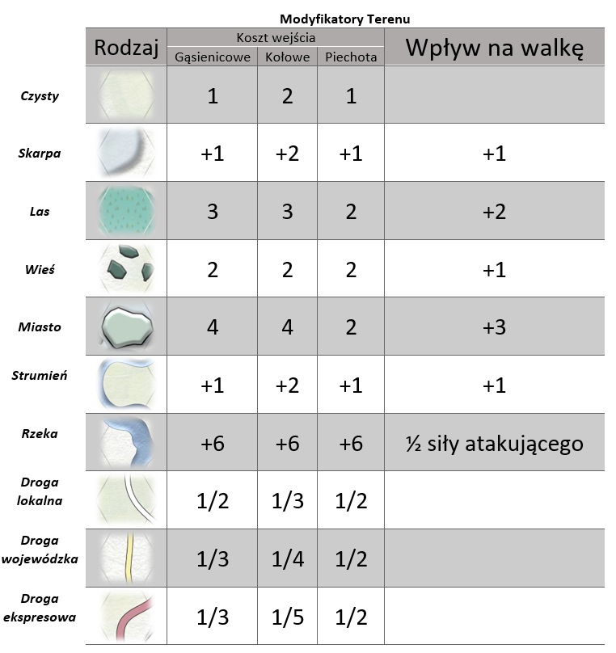

|  |  |  |  |  |  |
| --- | --- | --- | --- | --- | --- |
| ***Wzgórza*** |  | 2 | 3 | 2 | +1 |